Practice Exercise 1

1) Create a table name STUDENT with following structure.

|  |  |  |  |  |
| --- | --- | --- | --- | --- |
|  | Column |  |  |  |
| # | Name | Description | Data Type |  |
|  |  |  |
|  |  | Registration |  |  |
| 1 | RegNo | Number | NUMBER(3) |  |
| 2 | Name | Student Name | VARCHAR(15) |  |
|  |  | Gender of the |  |  |
| 3 | Gender | student | CHAR(1) |  |
| 4 | DOB | Date of Birth | DATE |  |
| 5 | MobileNo | Mobile Number | NUMBER(10) |  |
| 6 | City | Location of stay | VARCHAR(15) |  |

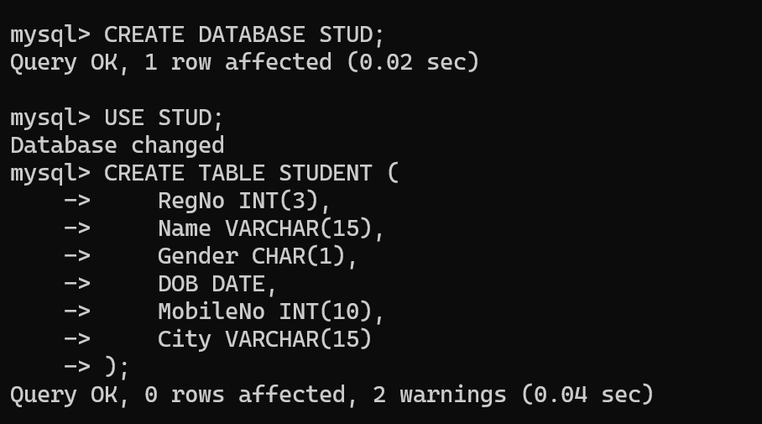

2) Create a table name FACULTY with following structure.

]

|  |  |  |  |  |
| --- | --- | --- | --- | --- |
|  | Column |  |  |  |
| # | Name | Description | Data Type |  |
|  |  |  |
| 1 | FacNo | Faculty Identifier | VARCHAR(4) |  |
| 2 | FacName | Faculty Name | VARCHAR(15) |  |
| 3 | Gender | Gender of faculty | CHAR(1) |  |
| 4 | DOB | Date of Birth | DATE |  |
| 5 | DOJ | Date of Join | DATE |  |
| 6 | MobileNo | Mobile Number | NUMBER(10) |  |

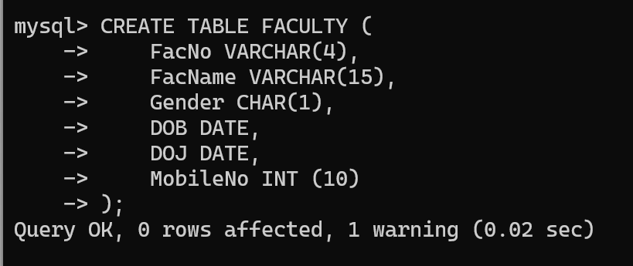

3) Create a table name DEPARTMENT with following structure.

|  |  |  |  |  |
| --- | --- | --- | --- | --- |
|  | Column |  |  |  |
| # | Name | Description | Data Type |  |
|  |  |  |
| 1 | DeptNo | Department Identifier | VARCHAR(4) |  |
| 2 | DeptName | Department Name | VARCHAR(15) |  |
| 3 | DeptHead | Department Head | VARCHAR(4) |  |

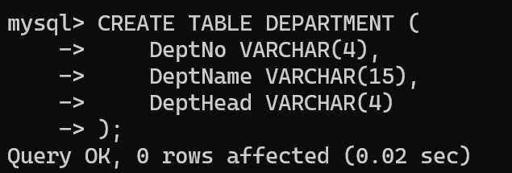

4) Create a table name COURSE with following structure.

|  |  |  |  |  |
| --- | --- | --- | --- | --- |
|  | Column |  |  |  |
| # | Name | Description | Data Type |  |
|  |  |  |
| 1 | CourseNo | Course Identifier | VARCHAR(3) |  |
|  |  | Course |  |  |
| 2 | CourseDesc | Description | VARCHAR(14) |  |
| 3 | CourseType | Course Type | CHAR(1) |  |
| 4 | SemNo | Semester Number | CHAR(1) |  |
| 5 | HallNo | Hall Number | VARCHAR(4) |  |
| 6 | FacNo | Faculty Identifier | VARCHAR(4) |  |
|  |  |  |  |  |

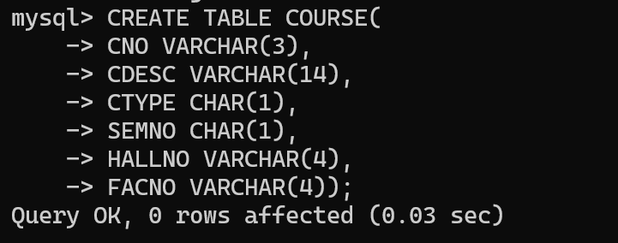

1. Modify the table FACULTY by adding a column name DeptNo of datatype VARCHAR(4)

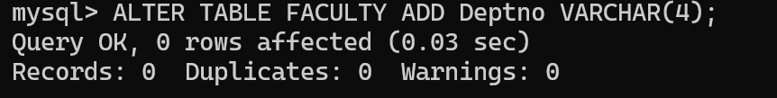

6) Alter the table STUDENT with following structure.

|  |  |  |
| --- | --- | --- |
|  | Column | Constraints |
| # | Name |  |
|  |  | PRIMARY |
| 1 | RegNo | KEY |
| 2 | MobileNo | NOT NULL |

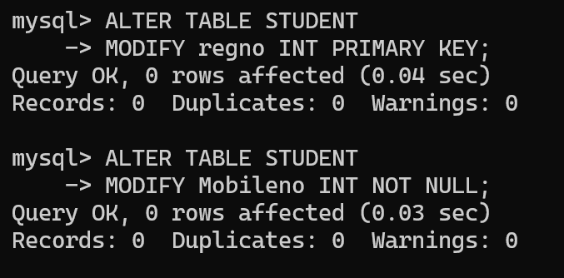

7)Alter the table name FACULTY with following structure. The DeptNo in this table refers the DeptNo in the DEPARTMENT table.

|  |  |  |  |  |  |  |  |  |  |  |
| --- | --- | --- | --- | --- | --- | --- | --- | --- | --- | --- |
|  |  | |  | Column | | Constraints |  |  |  |  |
|  | # | |  | Name | |  |  |  |  |  |
|  |  | |  | FacNo | | PRIMARY |  |  |  |  |
|  | 1 | |  | KEY |  |  |  |  |
|  |  |  |  |  |  |  |  |
|  |  | |  | Gender | | CHECK |  |  |  |  |
|  | 2 | |  | ‘  M’ or ‘F’ |  |  |  |  |
|  |  |  |  |  |  |  |  |
|  |  | |  | | | | | | |  |
|  |  | |  | | | | | | |  |
|  |  | |  | | | | | | |  |
|  | 8)After the FACULTY table is successfully, test if you can add a constraint created FOREIGN KEY to the DeptNo of this table. | | | | | | | | |  |
|  |  | | | | | | | | |  |
|  |  |
|  |  |
|  |  | |  |  |  |  | |  |  |  |
|  |  | |  | Column |  | Constraint | |  |  |  |
|  | # | |  | Name |  |  |  |  |  |  |
|  |  | |  | DeptNo |  | PRIMARY | |  |  |  |
|  | 1 | |  |  | KEY | |  |  |  |
|  |  |  |  |  |  |  |
|  |  | | 10) Alter the table name COURSE with following structure. | | | | | | |  |
|  |  | |  |  | |  | | |  |  |
|  |  | |  | Column |  | Constraint | | |  |  |
|  | # | |  | Name |  |  |  |  |  |  |
|  |  | |  | CourseNo |  | PRIMARY | | |  |  |
|  | 1 | |  |  | KEY | | |  |  |
|  |  |  |  |  |  |
|  | 2 | |  | SemNo |  | 1 to 6 | | |  |  |

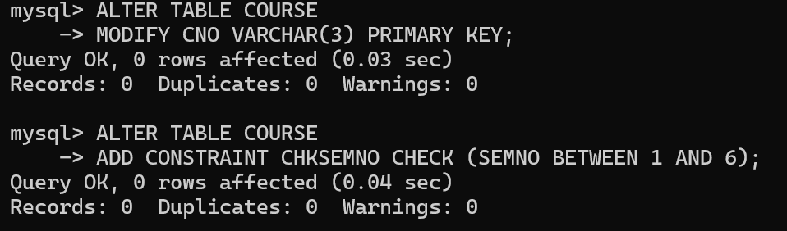

**Practice Questions**:

1. Populate all the five tables with your own data.

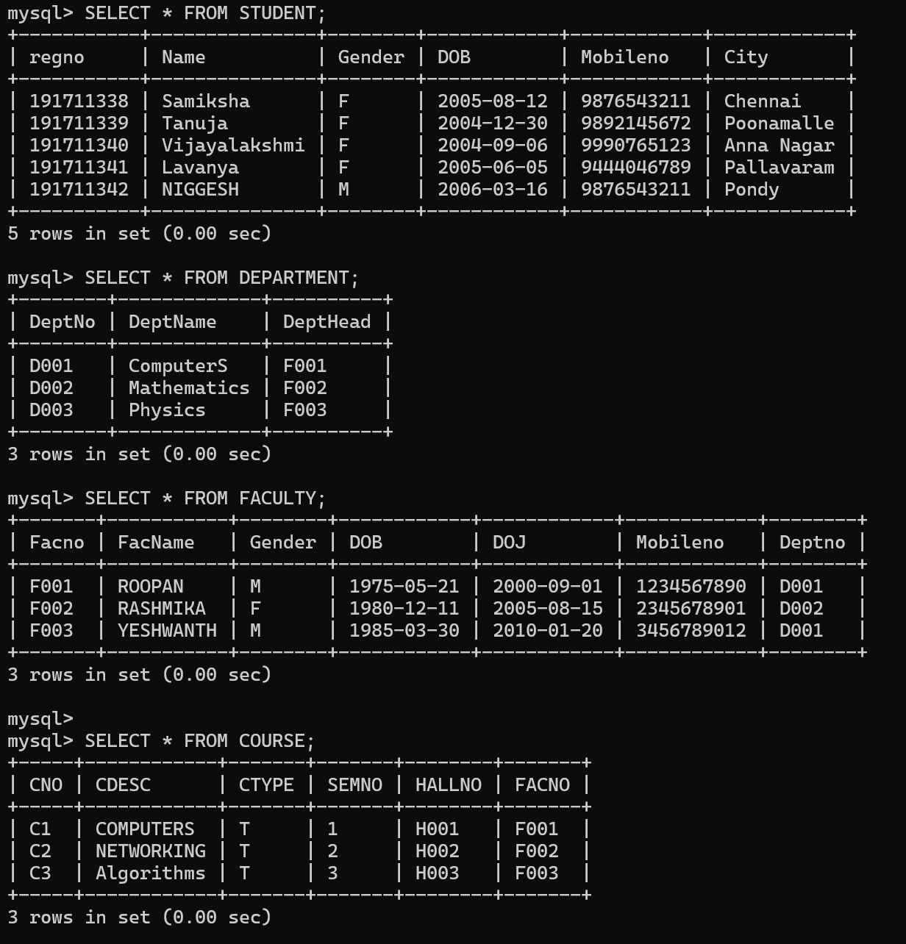

1. Update the value of student name whose register number is ‘191711342’

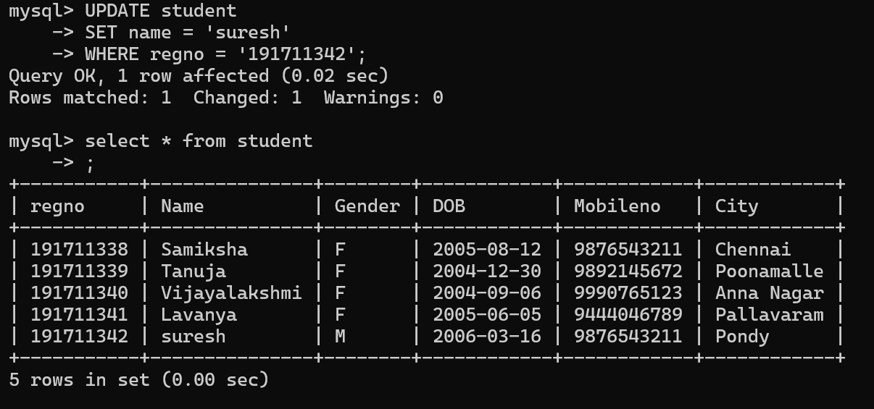

1. Delete the record in the table FACULTY, who resigned her job.
2. Modify the date of birth for the faculty whose name is 'RAM' with a value ‘1983-05-01’.

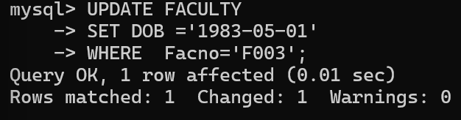

1. Remove all faculty who are having over 65 years

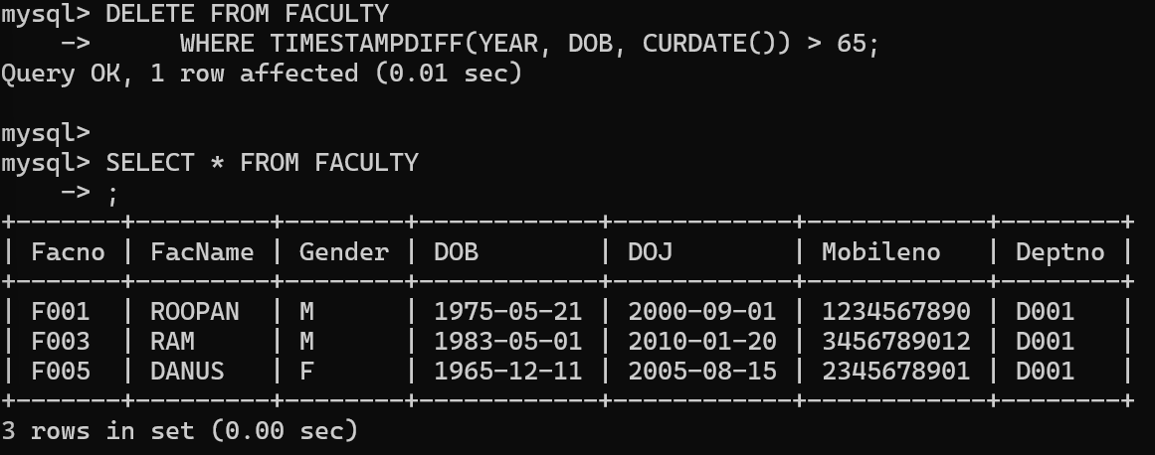

1. View all the records from the five tables.

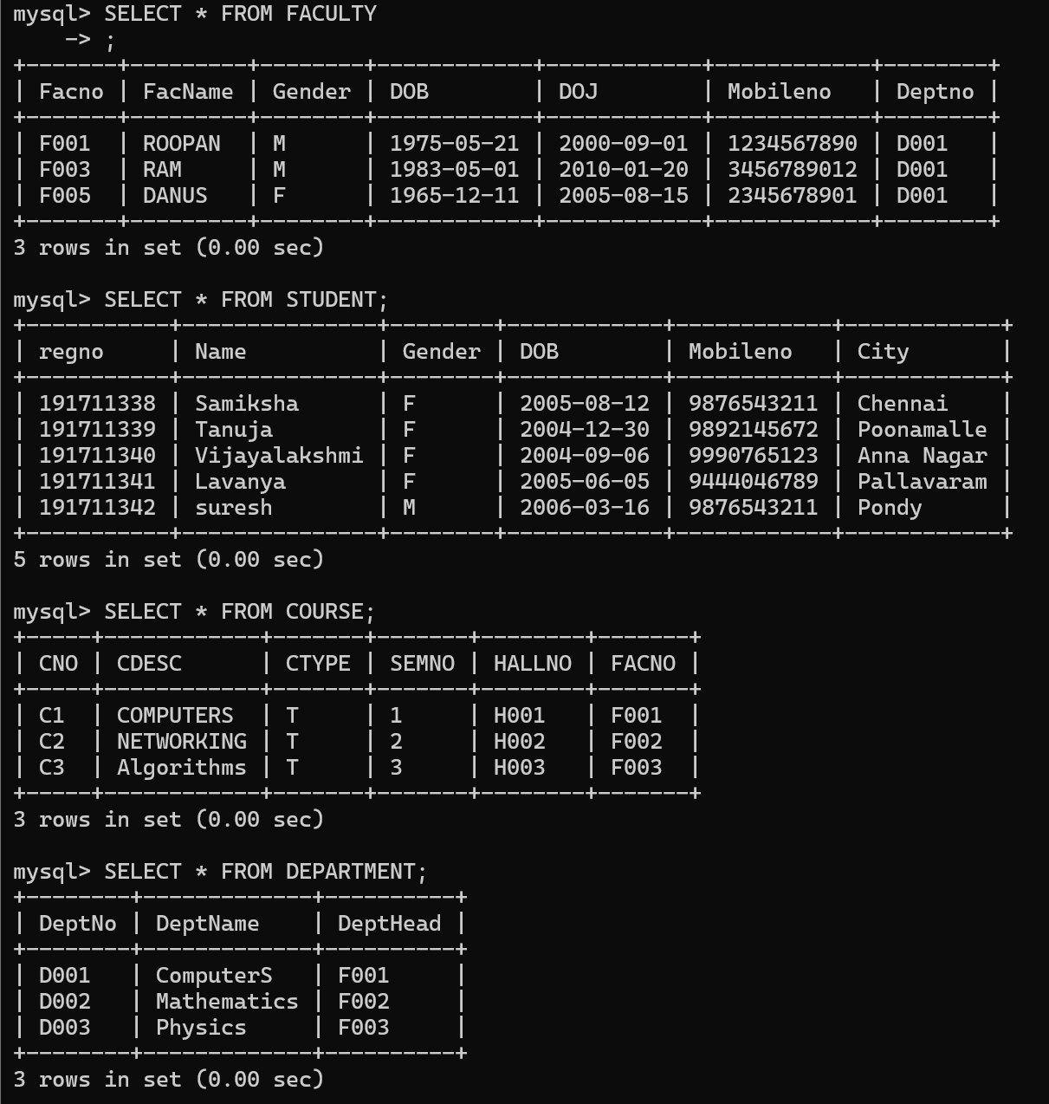

**WHERE Clause Questions::**

1. The student counsellor wanted to display the registration number, student name and date of birth for all the students.

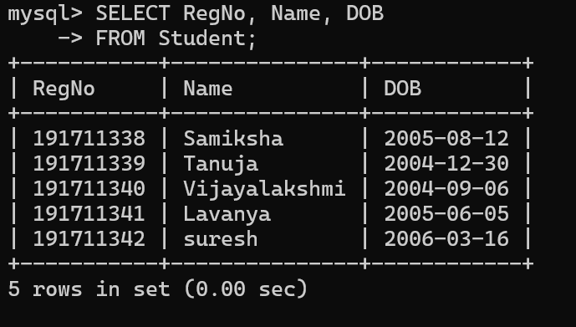

1. The controller of examinations wanted to list all the female students

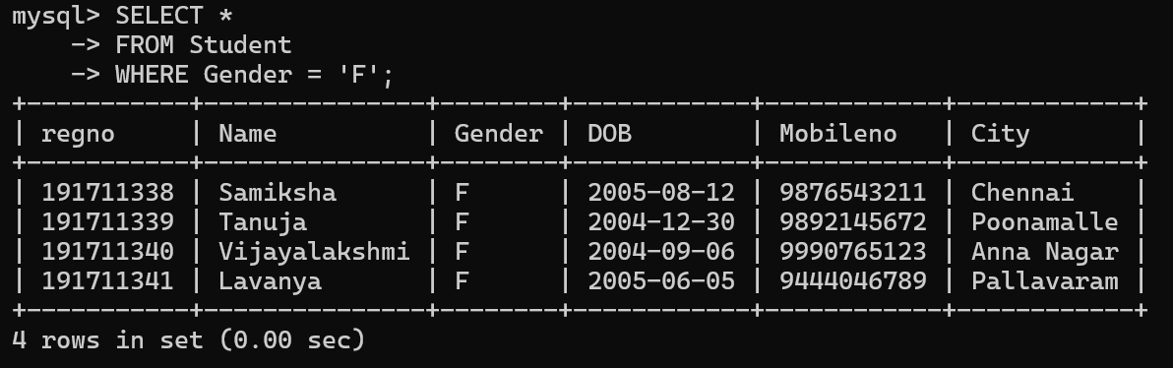

1. Who are the boy students registered for course with the course number “C00

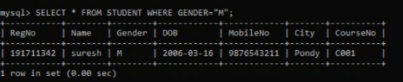

1. Display all faculty details joined before “November 2014”

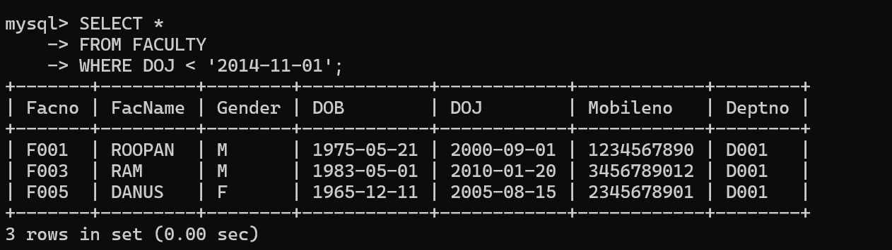

1. Display all the courses not allotted to halls

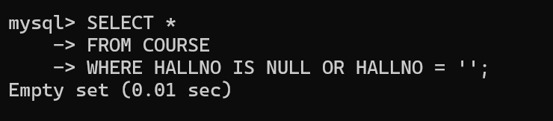

**LIKE Clause Questions::**

1. List the students whose name ends with the substring “ma”

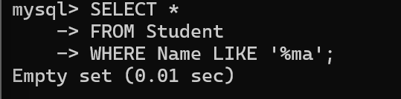

1. Display all students whose name contains the substring “ma”



1. Find all the students who are located in cities having “Sal” as substring

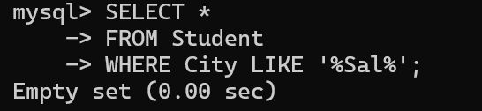

25.Display the students whose names do not contain six letters.

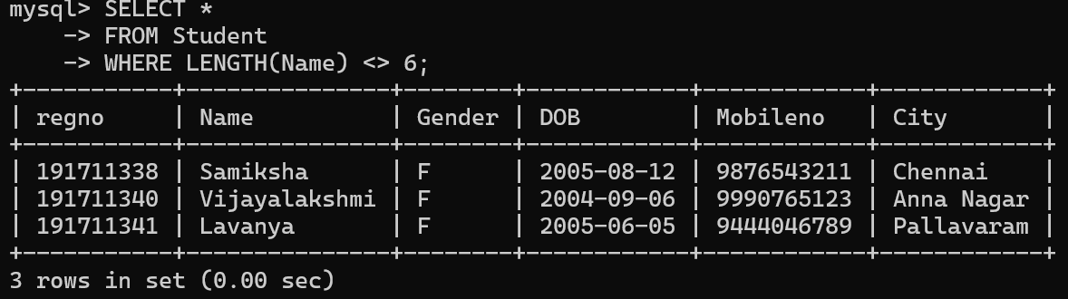

26.Find all the students whose names contains “th”

